What is the purpose of RWD?

Purpose of RWD is adjustability of webpages for all kind of devices with diferent screen measurements.

Why is it used?

If you open responsive design adjusted webpage on your smartphone, tablet, PC, it is still user friendly and you don’t need to scroll horizontally.

Iphone 5

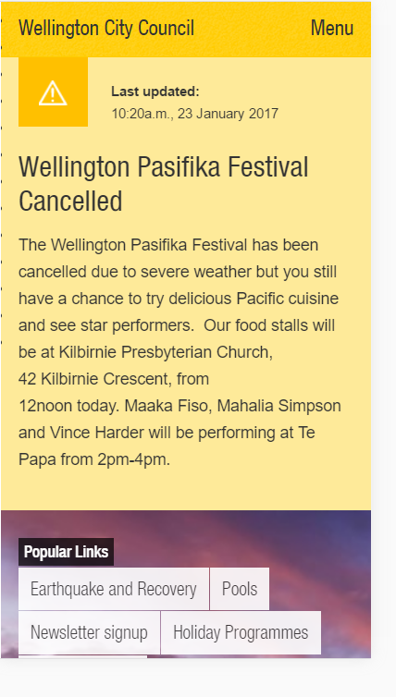

Ipad

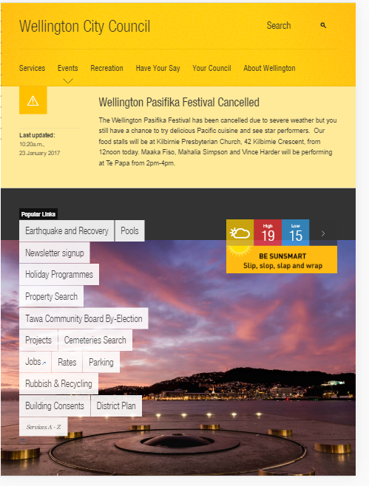

Before RWD?  
 Before RWD people were using static, adaptive, and liquid design

How css media queries can help you building reponsive web sites?  
 we can use media queries as „new“ css in the same document, they will be activated after page width reaches exact point eg <600px, then will be media query activated.

Why to use em (font) based sizing for example margins?  
 As we know every element using em units inherit size from it’s parent. Makes heir’s atributes related to parent‘s. This also works with every element of html document, e.g. border radius will adjust to border width etc...

2. RWD examples

Bostonglobe.com   
 iPhone 5  
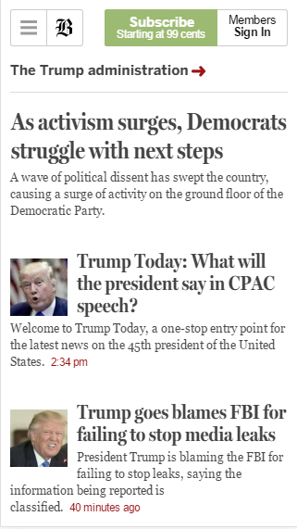

iPad pro  
